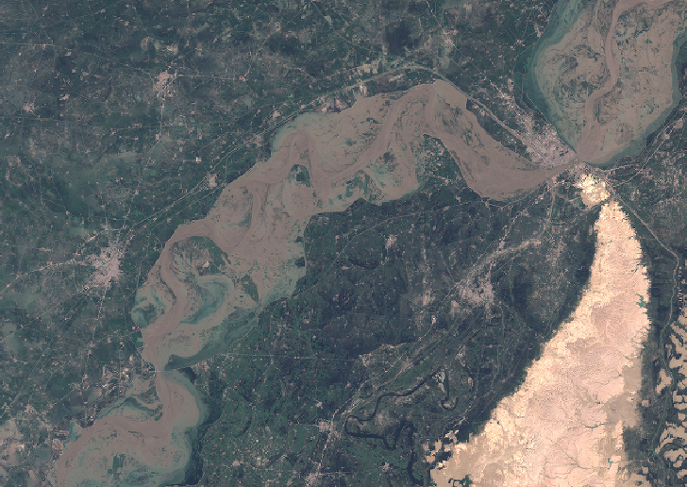

Adam Kerr

02 Dec 2022

Using satellite imagery and the Normalized Difference Water Index to analyze surface water changes

Analyzing flood water activity in Sindh Province, Pakistan

**Introduction/Literature Review**

More than 10% of the world’s population, about 1 billion people, live in an area subject to recurring floods. By the year 2050, that number could double due to a growing population and increasing severe weather. Floods are already the most deadly natural disaster in the world, causing the death of 6.8 million people during the 20th century (Singha et al., 2020). In fact, during the 20-year period from 1995 to 2015, of all weather-related disasters, flooding accounts for 53% of the total people affected, or over 2.2 billion people (Mateo-Garcia et al., 2021).

Remote sensing has provided an ability to monitor and assess water and flooding on the Earth since the Landsat mission in the 1970s (*Optical and Physical Methods for Mapping Flooding with Satellite Imagery | SpringerLink*, 2016). Landsat 1 launched in 1972 and marked the beginning of the era of earth-observing platforms specifically made to survey the earth (*Landsat 1 | U.S. Geological Survey*, 2022). The ability to quickly map floods and assess water conditions is crucial to increasing monitoring, planning, support, and recovery from flooding events. Remote sensing is one of the best ways to accomplish this (Xiao Huang, Cuizhen Wang & Zhenlong Li, 2018). Satellite and remote sensing technologies have advanced to a level where many hydrological features can be measured effectively, such as surface water levels, precipitation, soil moisture, evaporation, among others, giving those who manage water and weather conditions a plethora of data, even in low-income and data scare areas (Huang, 2018).

Many countries do not have infrastructure and water monitoring capabilities which leads to information gaps and unreliable water assessments. However, water detection techniques with satellites can help bridge this gap, especially in data-poor areas (Slinski et al., 2019). Some of the countries with the least amount of water information are actually the most vulnerable to water related crisis, including flooding (Sidder, 2019).

The normalized difference water index (NDWI) developed in 1996 gave remote sensing researchers the ability to visualize and quantify water features from land features more easily. It is calculated by taking the green band value minus the NIR values and dividing it by the green band values plus the NIR values (Gao, 1996). By using this method, remote sensing satellites can accurately delineate and measure water features by using spectral bands to define areas of water. The Normalized difference water index (NDWI) uses two multispectral bands to accomplish this by using a visible wavelength and dividing it most often by a near-infrared wavelength. Land and vegetation features are suppressed while water areas are enhanced, making it easier to identify and demarcate water features (Xu, 2006). While NDWI has proven very useful over the years, it has limitations, particularly when clouds are present as the visible and near-infrared wavelengths cannot passthrough the clouds. while flooding typically occurs when it is raining, this can hinder the usefulness of this method (Markert et al., 2018).

Flooding is a common occurrence during the annual monsoon season. Towns and people are accustomed to minor flooding near rivers and floodplains. Levees are built to contain the water and prevent it from entering towns and farmland. However, flooding in Pakistan during the monsoon season of 2022 caused immense destruction, damaging nearly 2 million homes, 1 million livestock, 1 million of acres of crops, and over 12,000 km (7,800 miles) of roads (*Pakistan and Its Submerged Cities*, 2022). According to the Pakistan Meteorological Department, rainfall for the month of August was 243% above average for the country as a whole. In fact, the rainfall in August alone was 37% more than the whole average monsoon season combined. While the national average was high, some areas received much more. Sindh province in the southeast received more than 700% more rainfall in August than normal, making in the wettest August on record ever (Fig 1). Additionally, Padidan, a town in Sindh province, received 14 inches on rain in one day in August. These extreme and torrential amounts of rain devasted towns, farmlands, and resulted in severe losses in food and properties.

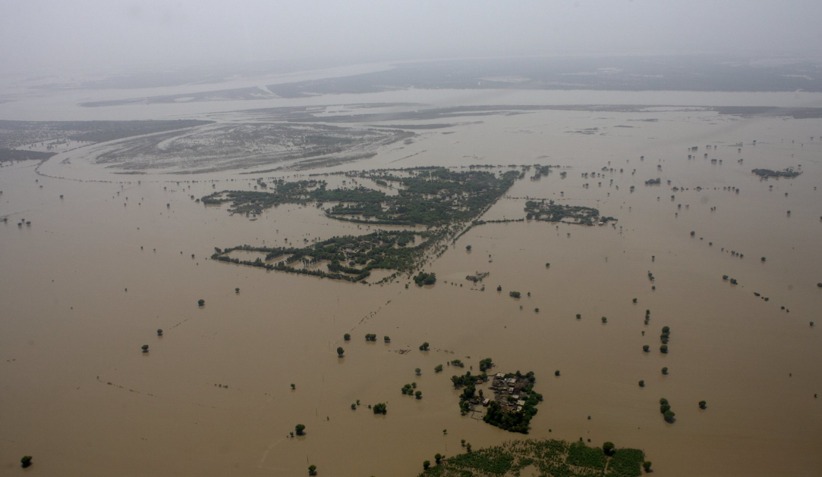

Figure 1. Flooding in Northern Sindh Province Pakistan, Aug 2022. Photo credit: Rob Holden / Department for International Development. (Flood Damage in Sukkur in Northern Sindh | Photo Taken by a … | Flickr, 2022)

The area of interest in this analysis is Shahdadkot, Pakistan. Shahdadkot is located about 50 kilometres northwest of Larkana and 34 kilometers north of Qambar, in northwestern Sindh province, which is in the Southeast of Pakistan. This city is the most populated within the Qamber Shahdadkot District, with a population of around 400,000 people. Rice is a common crop grown throughout this area, and the city is strategically important due to its location and activity within the trade routes of the area between Iran and Southeast Pakistan. The area was hit particularly hard due to the extreme amounts of rain during the 2022 monsoon season.

By using the NDWI, the extent and scope of flooding of this event can be observed, mapped, quantified, and compared to demonstrate the extent and magnitude of flooding events. Satellite image analysis can assist governments and aid organizations in understanding what areas are affected, how greatly, and in what time periods. Changes afterward can be monitored to assess the cleanup and return to normal conditions for safety and welfare.

**Method**

The assessment period utilized was 29 Jun 2022 and 02 Sep 2022. Sentinel 2 imagery was queried and downloaded for analysis. The images from 29 Jun were before the serious flooding began, and provided a baseline of typical conditions before monsoon season. The period within August during the worst of the flooding had poor visibility and was not utilized for this analysis. However, 02 Sep provided a clear view after the flooding occurred but had not receded to normal conditions. Climate data was obtained from the Pakistan Meteorological Department and provides a baseline for average rainfall during the month of August.

The downloaded imagery contains 13 bands, however, only band 3 (Green), band 8 (Near-infrared, NIR), and the True Color Composite (TCI) images were utilized (Fig 2. GISGeography, 2019). The TCI images themselves are quite drastic representations of the extent of the flooding observable from space and are useful proxies for visualizing the extent and magnitude of the floods. Additionally, ground level photographs taken by residents and reporters present a clear impact image at a detailed level.

However, the Normalized Difference Water Index (NDWI) highlights water features by comparing the green band and the NIR band values (Gao, 1996). Vegetation reflects both green and NIR wavelengths while water absorbs NIR wavelengths. By observing the difference between these values, water can be detected and analyzed for changes over periods of time. By observing the NDWI changes from Jun and Sep, we can see how much flooding has occurred within the area of interest.

Once the imagery is downloaded and bands are separated, it is processed via python scripting to extract NIR pixels within a certain value only. This represents areas where the NIR wavelengths are not being reflected, and likely water features. The amount of area is analyzed when comparing the Jun and Sep images to quantify the amount of flooding observed via satellite images. Additionally, histogram charts are used to show the changes between the two dates.

The geographic information system application QGIS is also utilized to create the NDWI via the Raster Calculator tool. This tool allows direct calculations of the NDWI by adding the green and NIR values and dividing by the green minus NIR values.

NDWI = Green – NIR

Green + NIR

Methodology Steps (Fig 3):

* Intro of data and available methods of analysis
* Acquiring data from Sentinel 2 using python scripts
* Merging TCI and NIR images, clipping images to area of interest
* Processing the data in python scripts, using NDWI method. For Sentinel 2 data, this is (Band 3 – Band 8)/(Band 3 + Band 8)
* Transcribe and interpret data, develop histograms and graphics using python
* Visualize data in graphs, images, photos

Figure 3. Methodology Overview

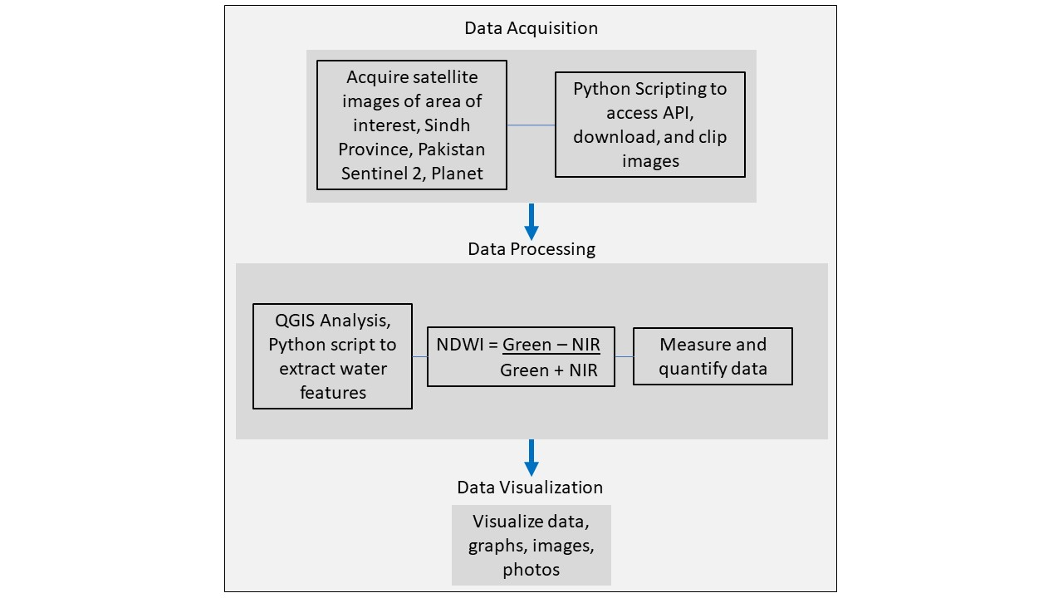

**Results:**

Upon observing the TCI images, it is clear flooding has occurred over a large portion of the area of interest. After processing the images with the NDWI for the two dates, vast differences appeared between the index values. Normal water distribution is observed on Jun 29, with a creek in the northwest and farmland to the east showing signs of typical water allocation with the majority of the area not showing any significantly wetness. However, on Sep 02, water covered the majority of the area, with only a few higher elevation areas remaining dry (Fig 4). Additionally, histograms created of the different dates show the variations between the images, particularly between the NIR band and the NDWI (Fig 5). These changes can also be observed in the TCI images, however, providing a measurable difference allows changes to be quantified and measured over time with increased accuracy.

Figure 4. True Color Image (left) and Normalized Difference Water Index (right) showing normal water distribution on Jun 29, then extensive flooding due to rain and breached levees on Sep 02. Yellow indicates significant water levels in the NDWI images.

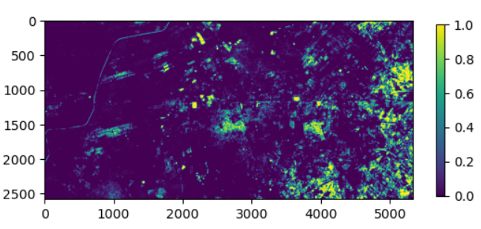

NDWI Jun 29

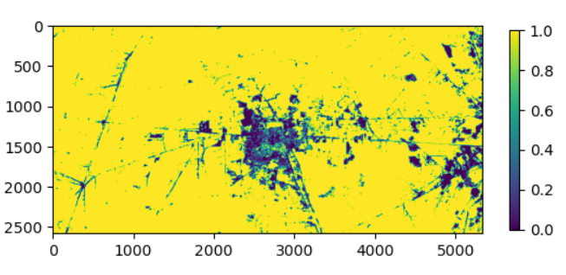

NDWI Sep 02

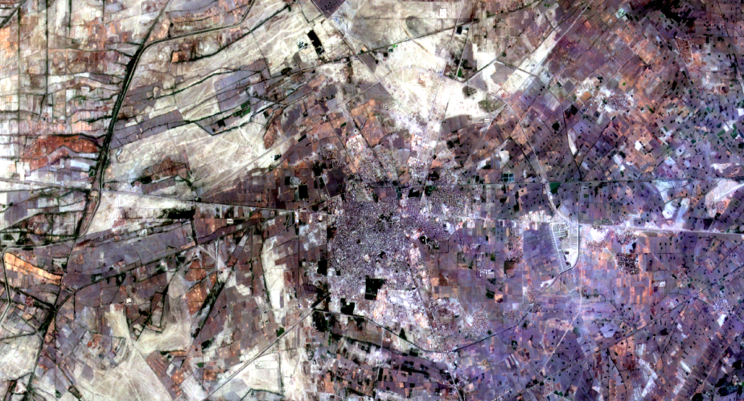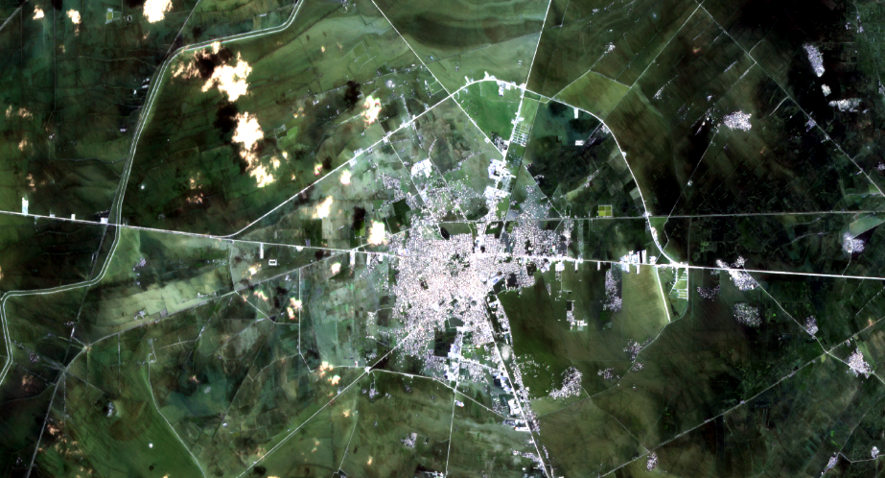

TCI Jun 29

TCI Sep 02

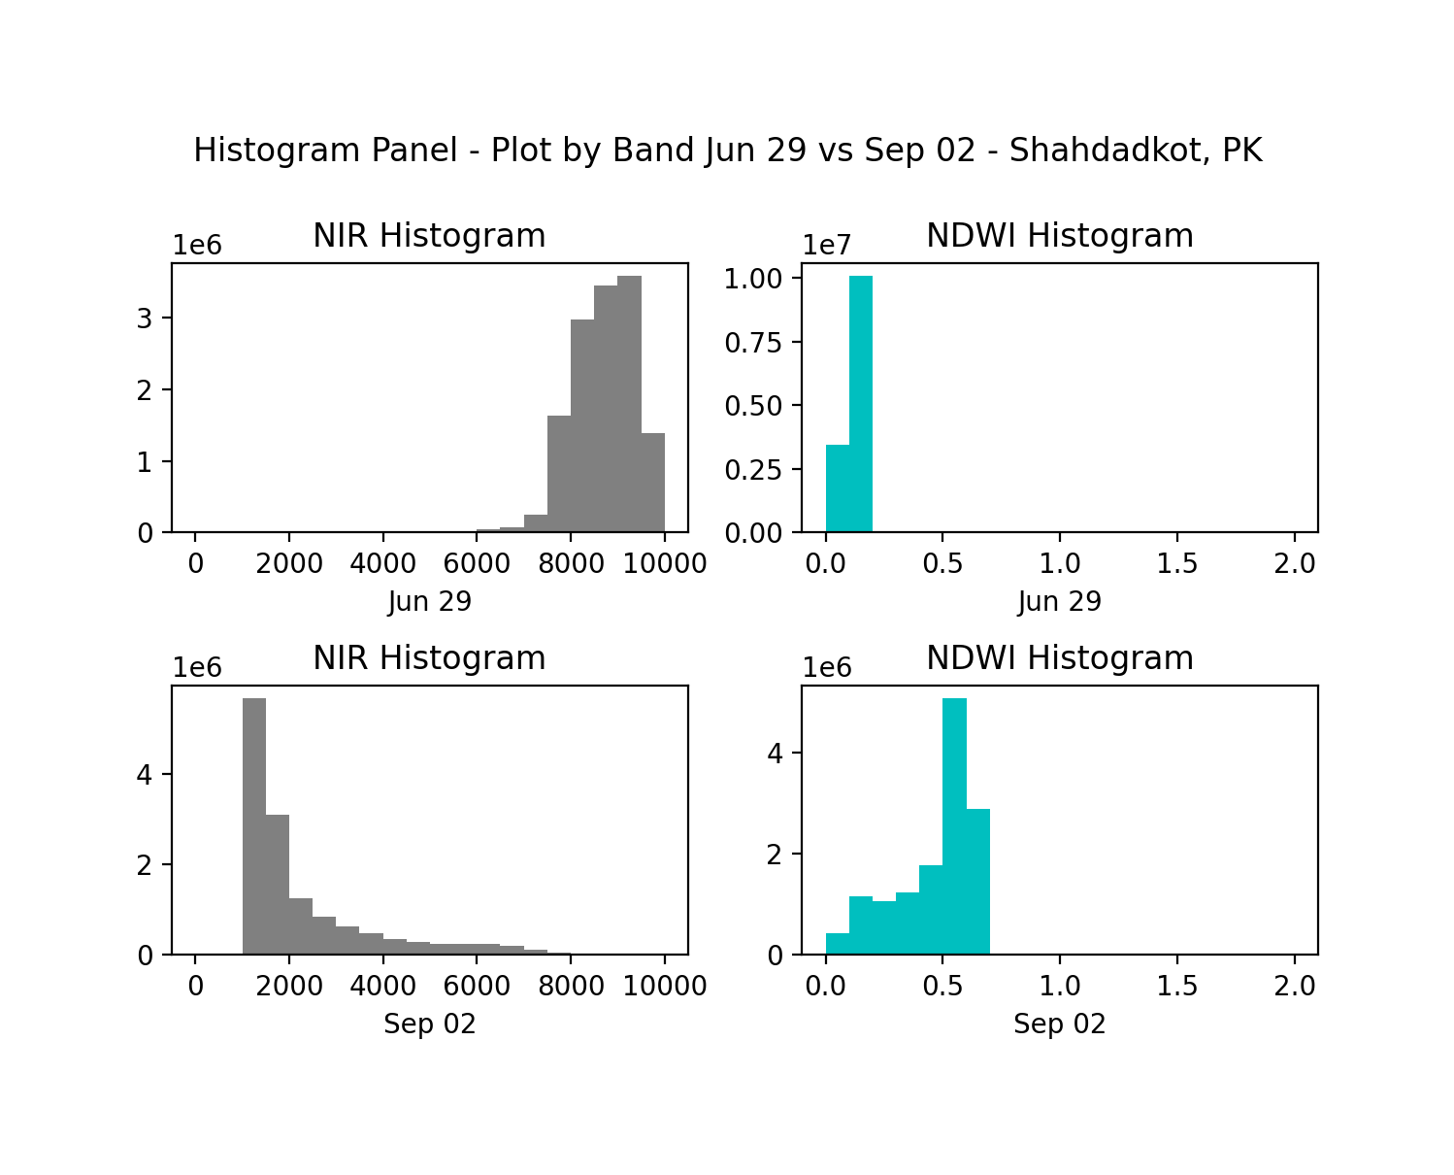

Figure 5. Histograms showing NIR reflectance and NDWI values for Jun 29 and Sep 02

**Conclusion:**

Using satellite imagery and NDWI can quickly assess where significant changes in water levels occur. This can assist governments and aid organizations in knowing where people and resources may be affected and can help to determine where to deploy resources. Especially in areas where monitoring and aid resources are scare and lacking, satellite image analysis can provide an economical assistance on a large scale when used in a timely manner. The amount of data coming online exceeds that ability to analyze it, but with further advances in machine learning and automated analysis, and developing the algorithms to train these systems such as the Normalized Difference Water Index, rapid deployment of information can help save lives, property, and resources as disasters increase due to expanding population and land usage, and climate change.

**Sources:**

Alsdorf, D. E., Rodríguez, E., & Lettenmaier, D. P. (2007). Measuring surface water from space. *Reviews of Geophysics*, *45*(2). https://doi.org/10.1029/2006RG000197

Fisher, A., Flood, N., & Danaher, T. (2016). Comparing Landsat water index methods for automated water classification in eastern Australia. *Remote Sensing of Environment*, *175*, 167–182. https://doi.org/10.1016/j.rse.2015.12.055

*Flood damage in Sukkur in northern Sindh | Photo taken by a … | Flickr*. (2022). https://www.flickr.com/photos/dfid/4974277482/in/photostream/

Gao, B. (1996). NDWI—A normalized difference water index for remote sensing of vegetation liquid water from space. *Remote Sensing of Environment*, *58*(3), 257–266. https://doi.org/10.1016/S0034-4257(96)00067-3

GISGeography. (2019, April 22). *Sentinel 2 Bands and Combinations*. GIS Geography. https://gisgeography.com/sentinel-2-bands-combinations/

Huang, C. (2018, August 1). *Seeing Surface Water From Space*. Eos. http://eos.org/editors-vox/seeing-surface-water-from-space

*Landsat 1 | U.S. Geological Survey*. (2022). https://www.usgs.gov/landsat-missions/landsat-1

Markert, K. N., Chishtie, F., Anderson, E. R., Saah, D., & Griffin, R. E. (2018). On the merging of optical and SAR satellite imagery for surface water mapping applications. *Results in Physics*, *9*, 275–277. https://doi.org/10.1016/j.rinp.2018.02.054

Mateo-Garcia, G., Veitch-Michaelis, J., Smith, L., Oprea, S. V., Schumann, G., Gal, Y., Baydin, A. G., & Backes, D. (2021). Towards global flood mapping onboard low cost satellites with machine learning. *Scientific Reports*, *11*(1), 7249. https://doi.org/10.1038/s41598-021-86650-z

*Normalized Difference Water Index: NDWI Formula And Calculations*. (2021, September 29). https://eos.com/make-an-analysis/ndwi/

Notti, D., Giordan, D., Caló, F., Pepe, A., Zucca, F., & Galve, J. P. (2018). Potential and Limitations of Open Satellite Data for Flood Mapping. *Remote Sensing*, *10*(11), 1673. https://doi.org/10.3390/rs10111673

*Optical and Physical Methods for Mapping Flooding with Satellite Imagery | SpringerLink*. (2016, November 4). https://link.springer.com/chapter/10.1007/978-3-319-43744-6_5

*Pakistan and its submerged cities*. (2022). https://graphics.reuters.com/PAKISTAN-WEATHER/FLOODS/zgvomodervd/

*Pakistan inundated*. (2022, September 1). https://www.esa.int/ESA_Multimedia/Images/2022/09/Pakistan_inundated

*Pakistan’s Monthly Climate Summary August, 2022*. (2022, August). https://www.pmd.gov.pk/cdpc/Pakistan_Monthly_Climate_Summary_August_2022.pdf

Patel, K. (2022, August 31). Why Pakistan’s record-breaking monsoon season is so devastating. *Washington Post*. https://www.washingtonpost.com/climate-environment/2022/08/31/monsoon-pakistan-flooding-explainer/

Sheffield, J., Wood, E. F., Pan, M., Beck, H., Coccia, G., Serrat-Capdevila, A., & Verbist, K. (2018). Satellite Remote Sensing for Water Resources Management: Potential for Supporting Sustainable Development in Data-Poor Regions. *Water Resources Research*, *54*(12), 9724–9758. https://doi.org/10.1029/2017WR022437

Sidder, A. (2019, April 8). *Improving Water Resources Management with Satellite Data*. Eos. http://eos.org/research-spotlights/improving-water-resources-management-with-satellite-data

Singha, M., Dong, J., Sarmah, S., You, N., Zhou, Y., Zhang, G., Doughty, R., & Xiao, X. (2020). Identifying floods and flood-affected paddy rice fields in Bangladesh based on Sentinel-1 imagery and Google Earth Engine. *ISPRS Journal of Photogrammetry and Remote Sensing*, *166*, 278–293. https://doi.org/10.1016/j.isprsjprs.2020.06.011

Slinski, K. M., Hogue, T. S., & McCray, J. E. (2019). Active-Passive Surface Water Classification: A New Method for High-Resolution Monitoring of Surface Water Dynamics. *Geophysical Research Letters*, *46*(9), 4694–4704. https://doi.org/10.1029/2019GL082562

*Spectral Characteristics Viewer | Landsat Missions*. (2022). https://landsat.usgs.gov/spectral-characteristics-viewer

Xiao Huang, Cuizhen Wang & Zhenlong Li. (2018, March 20). *Full article: A near real-time flood-mapping approach by integrating social media and post-event satellite imagery*. https://www.tandfonline.com/doi/full/10.1080/19475683.2018.1450787

Xu, H. (2006). Modification of normalised difference water index (NDWI) to enhance open water features in remotely sensed imagery. *International Journal of Remote Sensing*, *27*(14), 3025–3033. https://doi.org/10.1080/01431160600589179

Zhou, T., Haddeland, I., Nijssen, B., & Lettenmaier, D. P. (2016). Human-Induced Changes in the Global Water Cycle. In *Terrestrial Water Cycle and Climate Change* (pp. 55–69). American Geophysical Union (AGU). https://doi.org/10.1002/9781118971772.ch4